Basic Garment Pattern Design and the Development
For the Standard Figure
N. Nabeil. PhD A. Tahan .PhD
Faculty of Applied Arts.
Mansoura University, Egypt
tahan73@mans.edu.eg

Abstract
Every human model has pre-defined features, and the constructed garments are related to the features on human models .It is common that the measurements of any Human Figure are differing from the others with same size. Based on the parameters of flat curves and measurements of the flat pattern, geometrical approximation of the garment is achieved by reshaping the surfaces of the flat pattern, using the parabola curves as stating points between the armhole and the armscy. The formulas for constructing basic flat pattern designed and developed for the standard figure. Bearing in mind that, in reality there is no such thing as standard or perfect figure. It is, therefore, that whatever the type of pattern and the style of drawing pattern still have some fitting deficiency. From the point of view of tailored method (Manual) and engineering (geometric) construction method or by Computer (CAD), the research is trying to solve and overcome the problem of fitness and might put a step to solve this deficiency.
Key Words: patternmaking, armhole, armscy

Introduction
In sewing and fashion design, a pattern is an original garment from which other garments of a similar style are copied. It can also refer to the paper or cardboard templates from which the parts of a garment are traced onto fabric before cutting out and assembling (sometimes called paper patterns).The making of industrial patterns begins with an existing block pattern that most closely resembles the designer's vision. Patterns are cut of paper (usually from oak-tag or manila folder), punched with a hole and stored by hanging with a special hook. The pattern is first checked for accuracy, then it is cut out of sample fabrics and the resulting garment is fit tested. Once the pattern meets the designer's approval, a small production run of selling samples are made and the style is presented to buyers in wholesale markets. Once the style has demonstrated sales potential, the pattern is graded for sizes, usually by computer with an apparel industry specific CAD program. Following grading, the pattern must be fitted; the accuracy of each size and the direct comparison in laying seam lines is done. Once these steps have been followed and any errors corrected, the pattern is approved for production. When the manufacturing company is ready to manufacture the style, all of the sizes of each given pattern piece are arranged into a marker, usually by computer. The marker is then laid on top of the layers of fabric and cut. Once the style has been sold and delivered to stores – and if it proves to be quite popular – the pattern of this style will itself become a block, with subsequent generations of patterns developed from it.
By definition, ready-to-wear garment (RTW) is developed and offered for sale before potential costumer select and try on style of interest. Most sizing systems are derived from ASTM [1] .Even though, individual firms have always interpreted the standards differently in order to distinguish their garment from their competitors. Some people might be lucky enough to have their proportions being very close to the RTW values. This simply means that mass production apparel will fit these people pretty well. Other people, who are not that lucky [2, 3], will have difficulties finding a good fit in RTW. Since everybody is different, there is no such thing as a perfect formula for every type of figure, which is why it is custom design or Haute Couture [4]. The patterns commonly are constructed using specific formulas. Knowing one’s measurements, one would plug in the numbers to the formulas and build the pattern according to instructions of the choosing style. Pattern adjustment is the term used in the home sewing industry to refer to a variety of methods used to change dimensions of the paper pattern to more closely approximate the measurements of the wearer.
A sleeve pattern for example, may be lengthened or shortened according to the measured length of the person’s arm. Modifying garment length and width to accommodate cup size at the bust is also a common adjustment. Amount of ease for comfort and amount of ease for style are factored at making pattern adjustments. Improved fit from adjusted patterns may seem a logical result; however, the process of adjusting patterns requires advanced skills that typically require specific training or experience. Since sewing and pattern adjustment are skills not routinely taught in schools today and the knowledge is no longer passed from one generation to the next. However, most home sewers likely have limited access to gaining these skills. Hypothetically, therefore, typical home sewers might not have the skills to accomplish good fit of home-sewn apparel. Thus, the scenario of a home sewer investing considerable time and money to make a garment and then being frustrated with the fit is a very likely and an unfortunate outcome. If home sewers are not satisfied with apparel made from patterns, the industry will lose future sales. It is therefore useful to investigate factors that could contribute to satisfaction or dissatisfaction with pattern fit and final outcomes from adjusting patterns to improve garment fit.
The priority of the research is put some steps to solve the pattern deficiency of the different styles where is still experienced hand-drafted method or computerized. Even though, in the industrial mass production.

Previous Work
In the 1980s the home sewing industry in the USA suffered a downturn, which limited home sewing pattern selection available to the home sewer. The three major patterns companies – Simplicity, McCall’s, and Butterick – were each acquired in leveraged buyouts. An indication of the level of change was seen when Simplicity and McCall’s were sold multiple times.
A reaction to this industry transformation was streamlining offerings from these companies, putting emphases on home sewing, children’s patterns, and easy-to-construct patterns that do not require complicated fittings.
It is not surprising that a study was reported that 50-to-62% of women claim they cannot find apparel that fits [3, 5]. Apparel sizing and fit are difficult concepts to research and analyze where the relationship between the body and clothing is complex and often-ambiguous [6]. The current method of creating size and analyzing garment fit are according to the measurements of one ideal customer embodied in a single fit model .Moreover, adjusting the additional sizes consequently by using grade rules to define proportional increases and decreases from the base pattern. By different research [7], evaluation of the fit model could be visually and by two dimensions and comparing linear garment measurements to linear body measurements. Although these methods are useful for evaluating simple garment fit issues, they are not adequate to investigate the complexities of multifaceted relationship between the body and clothing for large number of customers with a variety of body types within each size.
Helen [8] developed a method called ‘visual sematometry’, which was aimed to improve the fit of costume made apparel. Her work also was directed towards the awareness of the relationship between body weight and fitness and various conditions of heart abnormalities. Technology has led to the development of non-contact measurement technologies [9, 10].
The emergence of sophisticated 3-dimentional body measurements technologies [11] and apparel CAD system has allowed major apparel retailer to use made-to-measure as a viable marketing tool.
Sungmin & Chang [12] have been seeking to present a new methodology to generate basic patterns of various sizes and styles using three-dimensional geometric modeling method. The geometry of a garment is divided into fit zone and fashion zone. The geometry of fit zone is prepared from 3D body scan data and can be resized parametrically. The fashion zone is modeled using various parameters characterizing the aesthetic appearance of garments. Finally, the 3D garment model is projected into corresponding flat panels considering the physical properties of the base material as well as the reducibility of the garment. The main findings were geometric modeling and flat pattern generation method for various garments. Parametrically deformable garment models enable the design of garments with various size and silhouette so that designers can obtain flat patterns of complex garments before actually making them. Also the number and direction of darts can be determined automatically considering the physical property of fabric.
Parametrically deformable garment models enable the design of garments with various size and silhouette so that designers can obtain flat patterns of complex garments before actually making them. Also the number and direction of darts can be determined automatically considering the physical property of fabric. The geometry of a garment is divided into fit zone and fashion zone. The geometry of fit zone is prepared from 3D body scan data and can be resized parametrically. The fashion zone is modeled using various parameters characterizing the aesthetic appearance of garments. Finally, the 3D garment model is projected into corresponding flat panels considering the physical properties of the base material as well as the producibility of the garment.
Sungmin & Chang [13] have found that, the generation of individually fit basic garment pattern is one of the most important steps in the garment-manufacturing process. They have developed a new methodology to generate basic patterns of various sizes and styles using three-dimensional geometric modeling method. They found that a piece of garment can restrict the movement of the wearer. The position of the point (under point of the armhole) is the crucial parameter that determines the dynamic ease allowance. Experiments have been conducted and the source of error most likely comes from the fact that the sleeve of the trial cover all garment cannot be stretched fully into a straight line.
Komárková & Musilová led a research of maternity [14] where pattern construction has been carried out by taking body measurements in relation to anatomical changes of female body during maternity. Eventually, the Results are applied into metric pattern construction of maternity clothes as Anthropometric data is analyzed as processed by statistical methods and correlation between body measurements. In case of different types of maternity wear the results applied for determination of pregnant women types. The data input as construction parameters setting to differentiate the body proportion of pregnant women. The principle of pattern construction of clothes for pregnant women is to consider the changes related to pregnancy as standard used method of pattern construction.
Roger and his colleagues [15] reported that dynamic ease allowance is the amount of spacing between the garment and the wearer that is required to allow the wearer to performance certain posture. Furthermore, without sufficient dynamic ease allowance, the motion of the wearer will be restricted. In this article, the authors present a single parameter model, which aims to calculate the minimal surface needed for performing some required postures. In this model, the boundary conditions based on the wrist and waist and an additional collocation condition is considered at the armhole. They emphasized that the minimal surface must pass through both end points (wrist and waist) and the collocation point (armhole).
By the technique of photographic data and computer technology, Chan & Huck [16] Explores the geometric nature of the upper female torso and physical measurements, to develop bodice patterns. By providing data for 12 female subjects participating in the study, they used the Body measurements, in addition to front and side view photographs. These data were used to develop the experimental methodology and a computer program to generate slopper patterns for the upper female torso. To compare the fit between the experimental and hand-drafted bodices they used a conventional pattern drafting method to develop hand-drafted bodice patterns. Eventually, an evaluation scale, which included 25 fitting criteria, was developed. They found that 12 of the 25 items on the scale, the experimental bodices judgment have a better fit than those produced by the hand-drafted method; for two items on the scale, the hand-drafted bodices fit better. Moreover, No statistically significant differences were found for the remaining items on the fit scale. They added that, this methodology shows potential for providing accurate, quickly-generated bodice patterns.
Fortunately, developments in information technology have increased the probability of mass customization being adopted as an acceptable business paradigm.
Cynthia [17] has reported that, Manufacturers have been struggling to meet the wants and needs of their customers without sacrificing the efficiencies and profits gained through mass production. On other words, every CAD system used in apparel patternmaking has some method that would enable mass customization through automatic alteration of patterns based on individual measurements.
Although ,the information technology as CAD systems has created an interface somewhat differently from all of the others; most have a number of basic activities in common that will allow “automatic” alterations to occur, in different words , to automatically customize garments for fit. Bye & McKinney [18] have carried out a research trying to develop a “good fit” for garments customer satisfaction, comfort, and functionality as well as a manufacturer's success and reputation. As more manufacturing, product development, and designing responsibilities continue to take place globally. They tried conducting Fit analysis using live and three-dimensional scan models as an alternative to the traditional fit analysis. They proposed a three-dimensional (3D) geometrical modeling algorithm based on the mapping of 2D objects on a 3D model. They reported that the methodology can be applied to the automatic modeling of many “secondary” garment parts like collars, waist bands, pockets, etc. They concluded that, the results obtained are accurate in relation to the original flat patterns, where, their approach is oriented towards the automation of the process of 3D garment modeling from flat patterns and consists in minimizing user intervention in the modeling process. Furthermore, this research evaluates garments on a live fit model and makes recommendations for the acceptance or modification of the garment for production.
Although there are many studies demonstrating consumer dissatisfaction with the fit of ready-to-wear apparel, few studies have focused specifically on the home sewing pattern industry, where this industry could benefit from further understanding of its customer base. Newcomb& Istook [19] have led a research for Home sewers attending home sewing expos in the states of Minnesota and Washington to determine satisfaction with fit of home sewing patterns and to determine factors that may affect satisfaction with the patterns. The paper seeks to explore home sewers' satisfaction with the fit of garments made from home sewing patterns and to provide useful information to the home sewing industry to improve products and services for the target consumer. They clearly indicate that these respondents were frustrated with the fit of home sewing patterns and that their efforts to adjust patterns for better fit were typically not successful. Although that they emphasized on the research limitations sample does not allow generalization, but may lend some insight into problems the home sewing pattern industry and may have in attracting and maintaining customer loyalty.
In spite of the computer system for made-to-measure pattern production should have the capability of determining default measurements for sets of customer measurements input to the system where one or more of these measurements are missing, but Chiricota [20] recommends the use of default formulae rather than mathematical interpolation of size charts. She recommended that these default formulae, when applied to a given size chart set, enable measurements to be determined efficiently over wide ranging customer sizes in both stature and girth. Although, she derived her research on the German DOB charts on Regular and Outsize charts and also for the full range of Height categories and Bust to Hip relationships, The specific default formulae has been applied in the Micro Fit made-to-measure system from Garment Micro Systems and also implemented for checking the validity of measurements entered into the system for each individual customer.
LaBat [21&22&23] and his colleagues conducted a research by focusing on examining the home sewers’ satisfaction with the fit of apparel produced from home sewing patterns and to determine whether home sewers believed that adjusting sewing patterns improved the fit of apparel made with the patterns. The results clearly indicate that these respondents were frustrated with the fit of home sewing patterns and that their efforts to adjust patterns for better fit were typically not successful. Multiple regression analyses were conducted using the stepwise method. They recommended that the new technologies in computer pattern fit methods may provide easier and faster methods for sewers wishing to use custom fit patterns. Still the question that, how much would a sewer be willing to pay for such a service? .Studies Schofield &Ashdown [24] have shown that women are least satisfied with the fit of pants.
As can be attributed to the outdated sizing standards based on decades-old anthropometric data used by apparel firms to create patterns, apparel consumers today have difficulties finding clothes that provide appropriate fit.
Turner & Bond [25] have guided A research study determines the inadequacies of ASTM sizing standards at meeting the needs of consumers in three target groups, segmented by age: Juniors, Missy, and Over 55
Chiricota [26] has derived a research for fast three-dimensional approximation of clothing
from flat patterns whilst his approach was implemented in a CAD program as currently used in the industry. By reshaping the surfaces of the garment and by using some curves as stating points as based on the parameterization of flat polygonal curves and measurements, a geometrical approximation is achieved. He applied these methods to model at different elements inherent to the field of clothing design, such as collars, lapels and waistbands. The algorithm methodology he utilized is made up of three parts. First, the polygons used to represent the pattern are measured. Second, a three-dimensional frame made up of spline curves that represent the garment, from 2-D measurements, is constructed. These curves are then used to form the Coons surfaces, which eventually serve as the initial conditions for a physical simulation.
The research of Newcomb and his colleagues [27] carried out by Using Body Shape Analysis Software (FFIT for Apparel), Size USA data and ASTM measurement data and analyzed for each of the three age groups. This methodology could allow for a greater understanding of the body shapes of target consumers. The research emphasized on the Revisions of the ASTM sizing standards based on this Size USA data would improve the fit of clothes, whilst, improve customer satisfaction, and enhance the business performance of apparel retailers as well.
Agins [28] has conducted An apparel program manager for the U.S. Navy has said that "quality control people at women's and children's apparel manufacturers report that the highest number of returns retailers get is because of size and fit. However, a focus simply on returns does not give a true indication of the fit problem. It is very hard to quantify losses related to lost sales, brand dissatisfaction, and time wasted in fitting rooms, which are all indicators of the costs of fit problems.
Harms and his colleague [29] present and validate a comprehensive modeling and simulation framework to predict recognition performance in casual loose-fitting garments. This research introduced a fundamental challenge limiting information quality obtained from smart sensing garments .The obtained information has a quit influence of textile movement relative to limbs. They have submitted a statistical posture and wrinkle-modeling approach to simulate sensor orientation errors pertained to local garment wrinkles where a metric was derived to assess fitting, the body-garment mobility. The fundamental research based on analyzing simulations of shoulder and elbow rehabilitation postures with respect to experimental data using actual casual garments. Their conclusion confirmed congruent performance trends with estimation errors below 4% for all study participants. The approach allows estimating the impact of fitting before implementing a garment and performing evaluation studies with it. They argued that the simulations revealed critical design parameters for garment prototyping, related to performed body posture, utilized sensing modalities, and garment fitting. Moreover that the modeling approach can substantially expedite design and can assist development of smart garments through early-stage performance analysis.
Beazley [30] explained in her 3 researches how to undertake an anthropometric survey, to obtain sizing and fitting systems .She recommended that ,a specialist knowledge is required to analyze statistically body measurements from surveys whilst control measurements, size ranges, body proportions and size intervals have to be calculated. She conducted a survey of 100 young women was undertaken in 1993/93 at Manchester Metropolitan University and 10 body measurements were taken. The result used [31] to illustrate the statistical analysis of body measurements, the formulation of sizing systems and body measurement charts. Size ranges and intervals were obtained by normalizing the data and comparing the sizes young women and previous size charts. Sizing systems were suggested for three heights, short, medium and tall and bust fittings medium, small and very small. A further system of changing proportion in girth measurements was developed from the survey of young women based on percentiles and bust fittings. The neck girth which did not correlate strongly with any measurement was analyzed separately.
Beazley submitted two examples of body measurement tables covering 30 measurements where formulated to illustrate the procedure. The results were analyzed statistically for body measurements especially in small surveys.
It was concluded that the body proportion had changed and the young women were taller and broader in the waist and hips. Beazley Continued her study [32] by comparing the problems of taking accurate body measurements with different equipment, formulating size charts for different garments and fabrics and relating these to different systems of pattern construction. Although she emphasized that the coding of sizes is still not uniform but finally, she applied these results for testing prototype garments for size and fit.
Wright [33] declared that a comfortable, attractive garment supposed to fits properly. It is neither too large nor too small and conforms to the contours of the body without binding, sagging, straining, or wrinkling. Pattern adjustment or alteration is often necessary to achieve good fit in a garment. Making adjustments or alterations before the garment is cut from fabric will eliminate many problems. Fitting problems usually involve one or more of these basic body areas: neckline, bust line, hipline, arms, shoulder line, back waistline, abdomen.
Related Benefits:
Hollen explained that Knowledge of pattern [34] will give increased understanding of such things as garment fitting, altering, correcting errors that might occur, in spite of, working out new procedures and organizing work efficiently specially at the familiarity of types of patters.
Anderson fashion innovativeness [35] and satisfaction with RTW and demographic variables were used to profile groups females based on body shape and fit preference. Length and tightness were the most common complaints for problems of fit with RTW regardless of the location. Results were significantly higher for having multiple rather than singular fit problems. ANOVA indicated statistically significant relationships between fit preference, body shape and body cathexis. Overall, female respondents who felt better about their bodies were more likely to select fitted clothing. Clothing benefits such as fashion innovativeness, fashion image and figure flaw compensation were associated with body shape and fit preference.
Types of patterns
- Flat pattern:
The work is done in a paper on a flat surface, hence the name. This type of pattern is a good method for beginners because the pattern is already has an established shape with the proper amount of ease. The beginner, therefore, does not have to be responsible for these factors. However, it is often helpful if the finished pattern is made up in muslin shell or other inexpensive material so the student can get the effect of the design being created or can see if the pattern is correct. Furthermore, before building up the flat pattern there is basic pattern.

The basic pattern:

A simple pattern that fits the body with just enough ease for movement and comfort,

where should be purchased in the proper size, alter to fit, made up as muslin shell and

checked for fit. The basic pattern is called a master or foundation pattern.

A slopper:

Is a cardboard copy of the basic pattern where restrictlly has dart areas and seam

allowances cut away that after to fit accomplished with the pivot or slash method of

flat-pattern designing.
2-Draping pattern:
This type of pattern is more advanced and is an artistic approach in which clothes are fit to
the curves of a dress from to make a cloth. The garment will look as the pattern develops.
3-Drafting pattern: -
This type of pattern is the issue of the present research. It is an engineering approach based
on a set of the body measurements. Accuracy of the pattern depends on the accuracy of the
measurements.
Experimental work
The ability to customize garments for garment fit is directly restricted to the availability of a comprehensive, accurate set of measurements. To obtain accurate physical measurements, a basic knowledge and set of skills are required that are hardly found in the average salesperson at a retail clothing outlet. The development of technology may have significant potential for use in the apparel industry, particularly for customization or mass customization strategies to be employed.
Strictlylly speaking, the hand is composed of the upper and lower arm which is covered by a sleeve. The sleeves can be set-in or grown-on. Set-in sleeve means that the sleeve is a separate piece of fabric sewn to the bodice of the garment at the armhole while the grown-on sleeve is an extension of the bodice. The generic sleeve is, therefore, defined to cover the arm from shoulder to wrist. The shape of the sleeve can restrict the movement of the arm where main cause of the restriction is due to the shape of the armhole of the sleeve.
In fact, the most accurate and the minimum steps should manipulate with the style of pattern, which require restriction of any major alteration.

Application
The research intended to use the pattern of female standard Measurement [36] size 40. Using the style of Maureen Goldsworthy [37] hand draft pattern, for the accuracy, the pattern has carried out by the computer CAM system (Investronica systems format).
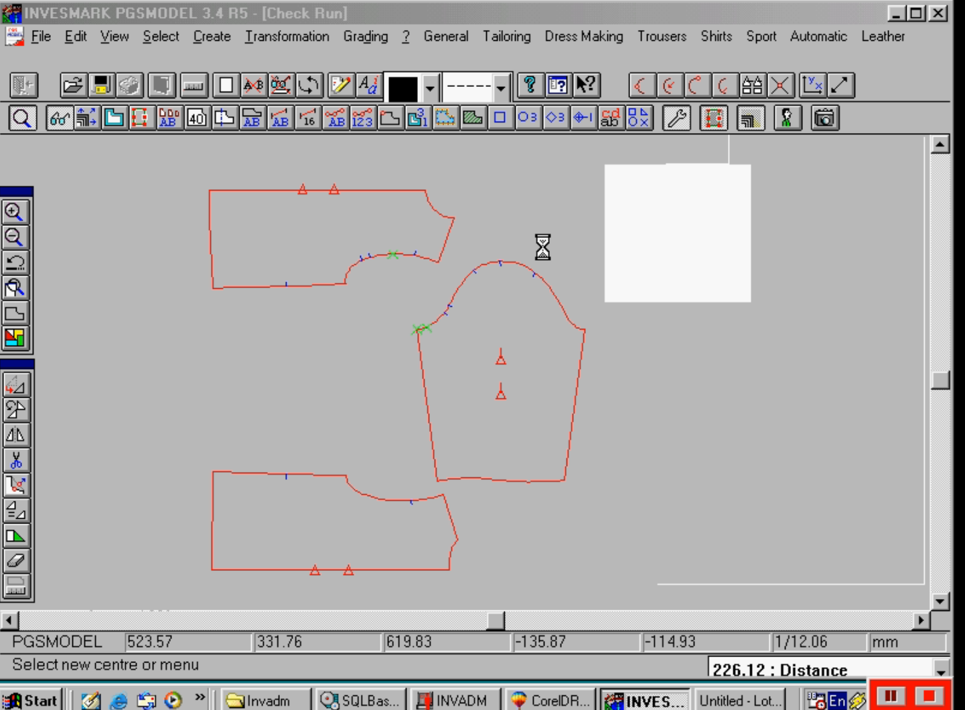
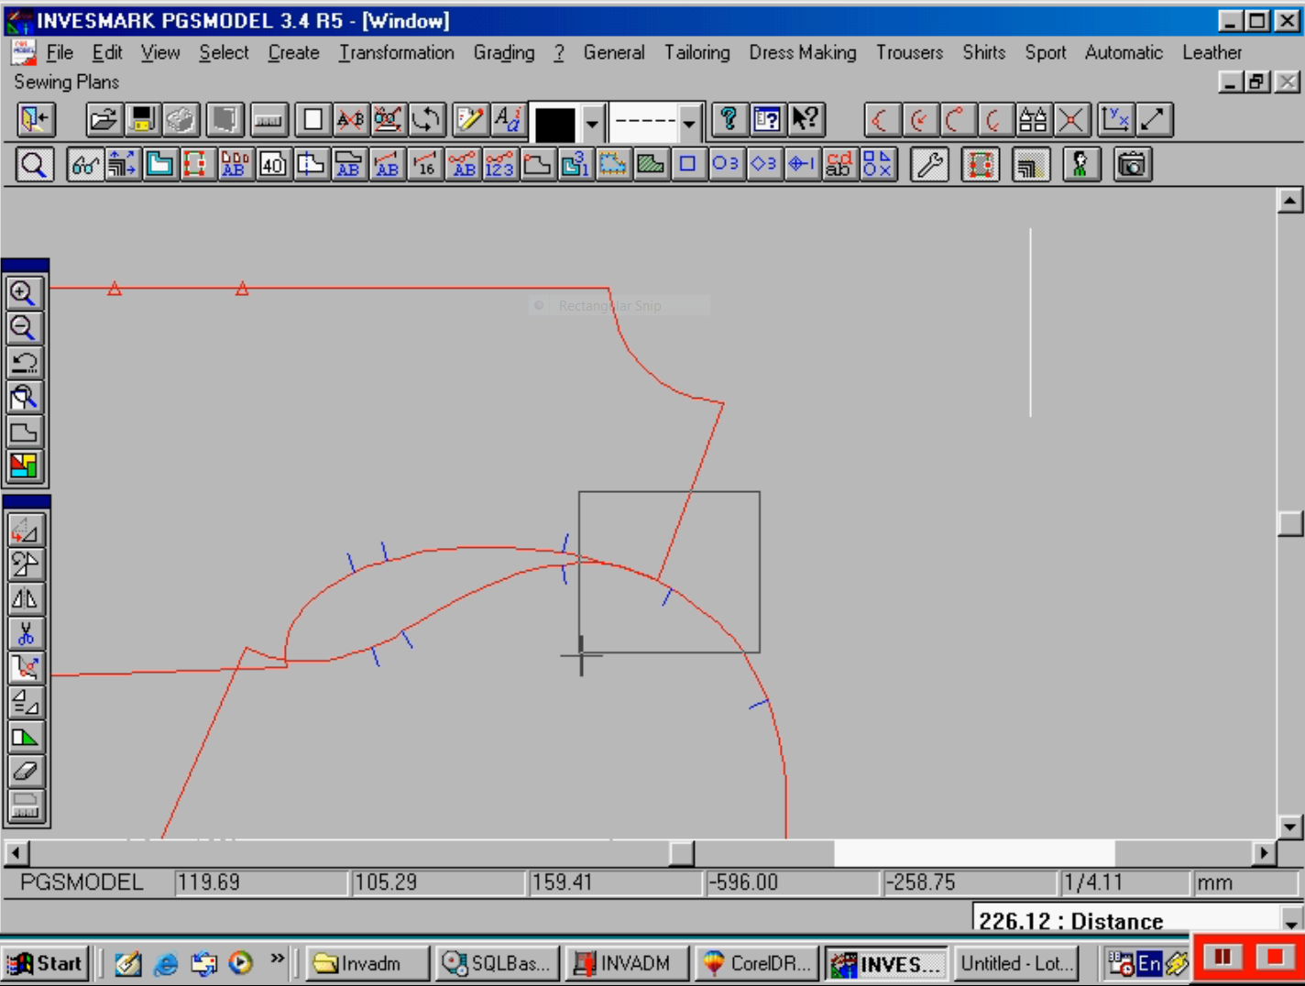

Fig (1) computer program Investronica sistemas

The facility of using the computer program is to measure any length on the pattern itself as shown at table (1), where it was intended to measure the length of WA (AC) and JN (AB) on the front and back pattern respectively Fig(2,3). It is known that all blocks automatically include the minimum amount of ease needed to accommodate comfortable movement. (The amount of ease for each measurement is indicated in on screen command information where the measurements commanded. The indicated amount is automatically added to the measurement to the entered data. It’s easily to increase or decrease the ease through adjusting the measurements as entered in to the computer.
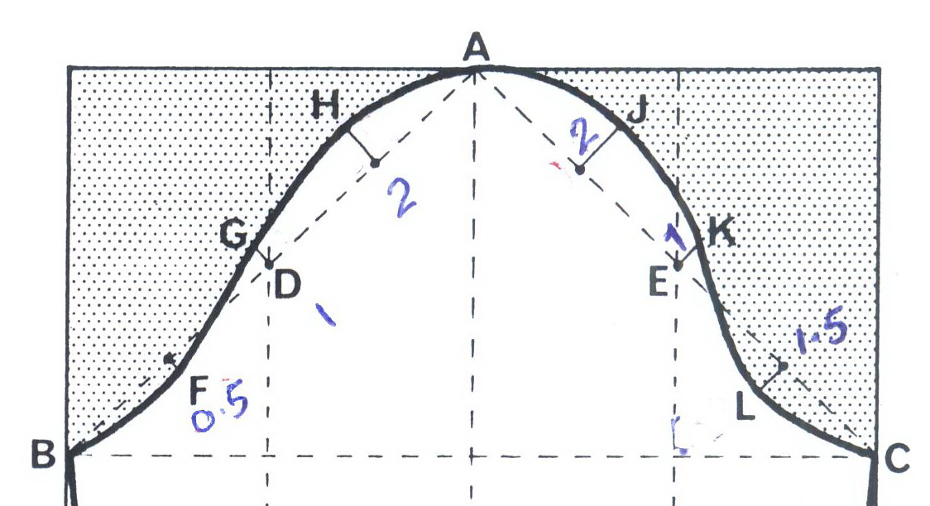
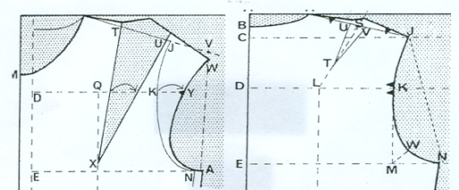

Front Back Back Front
Fig (2) Armhole Fig (3) Armscy

Table (1) showing the computer measurements in cm
The length of WA and JN on the front and back pattern
For both straight and curved line.
The curved line
Front armhole length  WA |  | Front armscy length  AC |  | Back armhole length  JN | Back armscy length  AB
19.9 |  | 24.0 |  | 22.4 | 23.5
The straight line
Length WA | Length AC |  | Length  JN |  | Length  AB
19.7 | 22.7 |  | 16.4 |  | 22.7

The results at table (1) showed that, the front curved armhole length (on the pattern Fig (2)) does not show the same of front curved length (on the sleeve at Fig (3)). In the meantime, the back armhole curved length JN Fig (2) does not the same of the back AB Armscy curved length Fig (3).Computer measurement differences between Front armhole length and Front armscy Length is 17% whilst back armhole length and back Armscy length is 4.7% .On the other hand, the straight line length of JN armhole and the straight line length of AC sleeve is 28% difference. Lastly, length of AB and length of WA is 13% difference. This is not the computer mistaken, but the common deficiency of the flat pattern itself, and it is thought that the whole styles of pattern varied from one to the others according to complicity of the manipulation and depend on the styles of the pattern itself.
The measurement logically, supposed to show that JN=WA = AC=AB as straight line, which is not, Just almost AC=AB whilst WA is longer than JN with almost 3.3 cm. this is really not accepted because this type of engineering style and the default will affect the entire pattern. According to these results, it is most of interest to work out for a new formula to solve mathematically this deficiency.

The mathematical analysis
Assumption
The length of line JKWN in the back pattern side, in Fig (1) is supposed to be equal the length of line AHGFB Fig (2).The length of line WA Fig (1) suppose to be equal the length of line AJKLC Fig (2), bearing in mind that the line AB is same of line JN in the back pattern .Assume that each line will be divided in two parts each equal 4 α where α ≠ 0 and α is a real number. In the front pattern, the line AC is the same of the line WA. Suppose the line AB and the line AC Fig (2) equals the X-axis as shown at the sketch of Fig (3& 4)

(1.0, 2α) (2.5, 3α) (1, 2α) (2, 3α)

Y
Y
A C A B

-1.5, α - 0.5, α
Fig (3) Front Fig (4) Back

Fig (3; 4) sketch shows the two parts of the crown of the
Sleeve and the points have to be altered indicated by the solid elevated lines

Because the dress fitting problem is experienced not the same length between the crown of the sleeve and the length of the armhole of the back and front of the block, the curved line AHGFB (back block) and the curved Line AJKLC (front block) each will be divided in two curves as shown in Fig (3, 4) by the dotted lines, one part is upward and the other is downward. Suppose that the equation of half of the sleeve crown is: Y=ƒ(X) where only real number will be used. The normal system of equation of Correlation is parabola and will be represented by equation (1) for the curves of both back and front pattern upward and the downward parts as well as follows.
Y = a + b x +c x² …….. ……. (1)
Where a, b and c are constant real numbers.
From the pattern design as assumed [10] that the length of AB=AC Fig (2).The number of reading points on the curve =3 as was determined according to the shaping of the sleeve head as the style has been drawn .The coordinate, therefore , will be as: (2, 0) & (1, 3.5 α) & (0, 4) for the back Armscy. Assuming that the origin of the curve started at the first of the highest point of the crown, i.e., at point (H). Substituting in equation (1), where the summation of the values is ∑ of each column at table (2).

Table (2) shows the data to be used with the equations 2,3,4

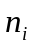 | 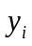 | 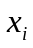 | 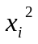 | 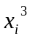 | 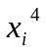 | 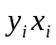 | 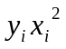
1 | 2 | 0 | 0 | 0 | 0 | 0 | 0
2 | 1 | 3.5α | 12.25α² | 42.9α³ | 150.1 α⁴ | 3.5α | 12.25α²
3 | 0 | 4α | 16α | 64α³ | 256 α⁴ | 0 | 0
∑ | 3 | 7.5α | 28.25α² | 106.9 | 406.1α⁴ | 3.5α | 12.25α²

To know the constant values of a, b and c, it is required to have three equations as follow:

n a + b ∑x+ c ∑x²= ∑y………… …… (2)
a∑x +b∑x²+c∑x³ = ∑xy…………………… (3)
a∑x²+b∑x³+c∑x⁴= ∑x²y…………………. (4)

For the estimation of the upward part of the curve of the armscy and solving the three equations (2, 3, and 4) together with the Gauss-Jordan method by using the matrix .By substituting the values of x and y from table (2) ,the matrix manipulated to find the constant parameters; then:

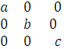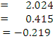

The parameters (a, b, c) will be equal:
a =2.024 & b =0.415 α⁻¹ and c = - 0.219 α⁻²
Then equation (1) will be as:
Y=2.024+ 0.415.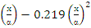 ……….. ..(5)
At. X=2α, X=3α and x= 4 α
The new values are 1.978 cm instead of 2 cm whilst 1.3 cm instead of 1.0 and 0.18 cm instead 0 cm at the end of the curve.
For the downward curve of the Armscy whilst bearing in mind that the intersection point will be assumed to be in the middle of the second division of the X-axis (- 0.5, α).
With reference to the known shaped point on the downward curve, the assumed points were determined as:
(0, 0) & as shown in table (3)

Table (3) shows the data to be used with the equations 2,3,4

1 | 0 | 0 | 0 | 0 | 0 | 0 | 0
2 | -0.5 | α | α² | α³ | α⁴ | - 0.5α | -0.5
3 | 0 | 1.5α | 2.25α² | 3.75α³ | 5.1α⁴ | 0 | 0
∑ | -0.5 | 2.5α | 3.25α² | 4.75α³ | 6.1α⁴ | - 0.5α | -0.5

Substituting values from table (3) to equations (2, 3, and 4) and solving those equations together by the matrix and obtain the constant parameters (a, b, c). It was found as:

a = - 0.482& b = 0.925 α⁻¹ and c = 0.891 α⁻²

Then equation (1) will be as:

Y= - 0.482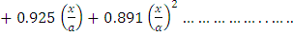(6)
This equation covered the curve (the armhole path) for the downward division of point (L) fig (2), whilst the pervious equation (5) covers the upper curve of the armhole path.
The new path is showed by the dotted line.
At X=α .The new value of Y= 1.334 cm instead of 0.5 that’s mean the curve is going to be deep and longer with 62.5% from the basic line.
By choosing the same steps on the path of the armhole for each side of the front Armscy and by manipulating the values of table (4)

Table (4) shows the data to be used with the equations 2, 3, 4

1 | 2.5 | 0 | 0 | 0 | 0 | 0 | 0
2 | 1.0 | 3.5α | 12.25α² | 42.9α³ | 150.1 α⁴ | 3.5α | 12.25α²
3 | 0 | 4.0α | 16.00α | 64.0α³ | 256.0 α⁴ | 0 | 0
∑ | 3.5 | 7.5α | 28.25α² | 106.9 | 406.1α⁴ | 3.5α | 12.25 α²

After solving equations 2, 3, 4 together by the matrix and obtain the constant parameters (a, b, c). It was found as:
a = 3.465 & b = 0.932 α⁻¹ and c = - 0.283 α⁻²
Then Y= 3.465+0.932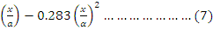
At X=2α, X=3α and x=4 α
The new values of Y= 2.52cm instead of 2.5 cm (i.e. 26%), 1.2 cm instead of 1.0 (20%) and 0.69 cm instead of 0 at the end of the curve.
For the smallest curve of the Armscy.

Table (5) shows the data to be used with the equations 2,3,4

1 | 0 | 0 | 0 | 0 | 0 | 0 | 0
2 | -1.5 | 1.0α | 1.00α² | 1.00α³ | 1.0α⁴ | -1.5 α | -1.5
3 | 0 | 1.5 α | 2.25 α² | 3.75α³ | 5.1α⁴ | 0 | 0
∑ | -1.5 | 2.5 α | 3.25 α² | 4.75α³ | 6.1α⁴ | -1.5α

After solving equations 2, 3, 4 together and obtain the constant parameters (a, b, c) the new values are:
a = - 2.48 & b = 0.053 α⁻¹ and c = 0.031 α⁻²
Then equation (1) will be
Y= - 2.48 +0.053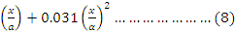
At X=α
The new value of Y= 2.39 cm instead of 1.5 cm (59.3%) that’s mean the curve is going to be deeper and longer also, bearing in mind that, the basic pattern is not dealing with the thickness of the fabric. This factor depends on the experience and professionality of the cutting and marker makers. It has to be considered with the other variables.

Conclusion
An important first step in understanding patterns is the mastery of the basic concept. However, it is basically understand that the Perfect style pattern never achieved in minutes even by experienced pattern cutters. One of the most important attributes of a good cutter, eventually, is the simplicity of manipulating such style patterns to extend their use. Suggestions, therefore, made where appropriate for using perfected style patterns as basic for other styles. However, the correct style of pattern should not need any major alteration, which is not true. The suggestion has been made by the present research might be to somehow solve the problem without any significant alteration.
The present research is a door open to other researcher to carry on that direction to minimize the women complain fitness.

References
- ASTM D5585-95-1995; D 192-98; D6240-98; D4910-99; D6458-99.
- Susenne L,Susan A. Katherine S. “Specific Analysis Of Body Scan Data To Improve Apparel Fit” .JTA TM-V4 (3) p(1-15) spring 2005
- Simmos k. “Female Figure Identification Part I (Development Of Shape Sorting Software)” JTATM-V4 (1) summer 2004.
- Haute Couture trifft Haute Joaillerie, magazin-z.ch, 24. November 2009
- Simmos k. “Female Figure Identification Part II (Development of Shape Sorting Software)” JTATM-V4(1) summer 2004.
- Keiser J. &Garner B. “Beyond the Design, the Synergy of Apparel Product Development” New York Fairchild Publication PP 303-324(2003)
- Locker S. Susan P& others. “Consumer Interest In Commercial Application Of Body Scan Data” , V4, issue 1.2004
- Helen D. “Visual Sematometry in Health Related Research”. Journal Of The Alabama Academy Of Science PP21-34-1977
- McKinnon &Istook C. “Comparative Analysis of the Image Twin System and The 3T6 Body Scanner” JTATM,V(1)&(2) winter 2001
- Devarajan P. “Validation Of Female Figure Identification Technique (FFIT) For Apparel Software” .JTATM,V4,Issue 1, summer 2004
- Tahan A. Zalat A. “Comparison Study of Different Of Pattern Design and the Most Applicable To Mansoura University Students Figures”. Home Economic 7th Scientific Conference Helwan University-Egypt, 21/22 April 2002.
- Hardy H & Jesen M. “Theory without Pain. Provo Utah. Brigham Young” .U.K University Press (p7) 1976.
- Sungmin K & Chang P. "Basic garment pattern generation using geometric modeling method", International Journal of Clothing Science and Technology, Vol. 19 Issue: 1, pp.7 - 17(2007).
- Komárková P & Musilová B. Pattern Constructions of Maternity Wear 7th International Conference - Texsci 6-8, September (2010) Liberec, Czech Re.
- Roger N & Winnie Y. & Cheung L. “Single Parameter Model Of Minimal Surface Construction For Dynamic Garment Pattern Design”. Journal of Information and Computing Science Vol. 2, No. 2, pp. 145-152.( 2007)
- Shen L. Huck J. "Bodice Pattern Development Using Somatographic and Physical Data", International Journal of Clothing Science and Technology, Vol. 5 Issue: 1, pp.6 – 16.(1993).
- Cynthia I. “Enabling mass customization: computer-driven alteration methods", International Journal of Clothing Science and Technology, Vol. 14 Issue: 1, pp.61 – 76.( )
- Bye, E. & McKinney, E. "Fit analysis using live and 3D scan models", International Journal of Clothing Science and Technology, Vol. 22 Issue: 2/3, pp.88 – 100. (2010).
- Newcomb E. Istook C. "Confronting stereotypes: apparel fit preferences of Mexican-American women", Journal of Fashion Marketing and Management, Vol. 15 Issue: 4, pp.389 – 411. (2011).
- Chiricota Y. "Three-dimensional garment modeling using attribute mapping", International Journal of Clothing Science and Technology, Vol. 15 Issue: 5, pp.346 – 358. (2003).
- LaBat K. Salusso C. Rhee J. "Home sewers' satisfaction with fit of apparel patterns", Journal of Fashion Marketing and Management, Vol. 11 Issue: 3, pp.429 – 440. (2007).
- LaBat K. and DeLong M. “Body cathexis and satisfaction with the fit of ready-to-wear apparel”, Clothing and Textiles Research Journal, Vol. 23 No. 1, pp. 13-27. (1990),
- LaBat K. “Consumer satisfaction/dissatisfaction with the fit of ready-to-wear clothing”, unpublished doctoral dissertation, University of Minnesota, St Paul, MN (1997).
- Schofield N, Ashdown S., Hethorn J., LaBat K. and Salusso C. (2006), “Improving pant fit for women 55 and older through exploration of two pant shapes”,
Clothing and Textiles Research Journal, Vol. 24 No. 2, pp. 147-60.
- Turner J, Bond T. "Made-to-measure garments for ladies – catering for wide ranging stature and length measurements for standard and outsize ladies", International Journal of Clothing Science and Technology, Vol. 11 Issue: 4, pp.216 – 225. (1999).
- Chiricota Y. Cochaux O. Provost A. Geometrical modelling of garments. International Journal of Clothing Science and Technology Volume: 13 Issue: 1 .(2001).
- Newcomb B, Istook M. “A Case for the Revision of U.S. Sizing Standards”. Journal of Textile and Apparel, Technology and Management. Volume 4, Issue 1, summer 2004.
- Agins T. “Go figure: Same shopper wears size 6, 8, 10, 12”. Wall Street Journal, pg. 1-4, November 11(1994).
- Harms H. and Amft O. Tröster G “ Estimating Posture-Recognition Performance in Sensing Garments Using Geometric Wrinkle Modeling.Information Technology in Biomedicine”. IEEE Transactions Vol: 14 Issue:6 .page: 1436 - 1445 Nov. (2010 ).
- Beazley A. “Size and fit: procedures in undertaking a survey body measurements”, Journal of Fashion Marketing and Management, Vol. 2 No. 1, pp. 55-85. (1997).
- Beazley A. “Size and fit: formulation of body measurements tables and sizing systems”, Journal of Fashion Marketing and Management, Vol. 2 No. 3, pp. 260-84(1998).
- Beazley A, “Size and fit: the development of size charts for clothing”, Journal of Fashion Marketing and Management, Vol. 3 No. 1, pp. 66-84. (1999).
- Wright S. “Cooperative Extension Service College of Agriculture and Home Economics Guide” C-228 Reprinted April 2001
- Hollen R. “Pattern Making By the Flat-Pattern Method 5th Edition”. Burgess publishing companies .Minneapolis Minnesota ISBN 0-8087-3173-4(1981)(p10).
- Anderson L, Brannon E., Ulrich P., Presley A. Woronka D. Grasso M ; Stevenson D “Understanding Fitting Preferences Of Female Consumers: Development An Expert System To Enhance Accurate Sizing Selection”. National Textile Center Annual Report: I98-A08 November 2001.
- EOSQ - Egyptian Organization for standardization and Quality Control 2002.
- Goldsworthy M. “Simple Dressing Shirt and Blouse”. Mills &Boon Ltd15-16 Brook London W1Y 1LF ISBN 0-263-06425-5 (1980).
- Compton N & Hall O. “Foundations of Home Economics Research” Minneapolis: Burgess Publishing Company 1977(P9).

